

**North South University**

Department of Electrical and Computer Engineering

**RFID Controlled Smart Security Door**

**Group Members:**Kazi Abdullah Al Hasnaine - 2211688 642

Md. Asaduzzaman Sunny - 2211702 642

Jalal Abedin Pial - 2211158 642

Showkat Osman - 1921993 042

**Course Code:** CSE331

**Course Title:** Microprocessor Interfacing & Embedded System

**Faculty:** Dr. Mainul Hossain

**Instructor:** Rokeya Siddiqua

**Introduction:**

This project focuses on developing a Security Door Access System using an STM32 microcontroller. The system’s primary objective is to provide a reliable and efficient method for restricting access to authorized individuals only.

**Main Project Goals:**

1. Enhance Security – Prevent unauthorized access by implementing RFID-based authentication.

2. Provide Real-Time Feedback – Use an OLED display to inform users of authentication status.

3. Automate Door Operation – Control a servo motor to lock or unlock the door automatically.

4. Presence Detection – Ensure the system only activates when a person is detected in front of the door, preventing unnecessary operation or false triggers.

5. Ensure System Reliability – Maintain stable and consistent performance through efficient microcontroller programming.

6. Scalability – Design the system so it can be expanded to support more users or integrate with additional sensors and security features.

This solution is suitable for residential, commercial, or institutional environments where controlled access is essential, offering a cost-effective and easily maintainable approach to improving security.

**Components Used:**

This project integrates various electronic components to build a secure, automated door access system controlled by an STM32 microcontroller.

**RC522 RFID Module:**

Reads RFID cards to identify authorized users, enabling secure access control by allowing only recognized cards to unlock the door.

**Ultrasonic Sensor (HC-SR04):**

Detects the presence of a person near the door by measuring distance, ensuring the system only operates when someone is in front, preventing unnecessary activation.

**OLED Display (SSD1306):**

Provides real-time feedback by displaying messages such as “Access Granted” or “Access Denied” to inform users of their authentication status.

**Servo Motor:**

Controls the door locking mechanism by physically moving the lock to open or close when authorized access is granted.

**External LED:**

Used as a visual indicator to show system status or activity, such as blinking during authentication or door operation.

**Buck Converter:**

Supplies stable 5V power from a higher voltage source to power components like the servo motor and ultrasonic sensor safely and efficiently.

**STM32 Blue Pill Microcontroller:**

Acts as the central controller of the system, processing inputs from the RFID reader and ultrasonic sensor, controlling the servo motor, OLED display, and LED to manage secure door access.

**Implementation:**

Code: (Arduino IDE)

#include <SPI.h>

#include <MFRC522.h>

#include <Wire.h>

#include <Adafruit_GFX.h>

#include <Adafruit_SSD1306.h>

#include <Servo.h>

// OLED Config

#define SCREEN_WIDTH 128

#define SCREEN_HEIGHT 64

#define OLED_RESET -1

Adafruit_SSD1306 display(SCREEN_WIDTH, SCREEN_HEIGHT, &Wire, OLED_RESET);

//leds

#define RED_LED PB12

#define GREEN_LED PB15

// RFID Config

#define RST_PIN PB0 // RC522 RST

#define SS_PIN PA4 // RC522 NSS

MFRC522 mfrc522(SS_PIN, RST_PIN);

// Ultrasonic Pins

#define TRIG_PIN PA2

#define ECHO_PIN PA1

// Servo

Servo myservo;

// Card UIDs

byte cardA[4] = {0x06, 0xCC, 0x87, 0x97};

byte cardB[4] = {0x03, 0x96, 0x41, 0xC5};

void setup() {

// Init SPI for RFID

SPI.begin();

mfrc522.PCD_Init();

// Init OLED

Wire.begin();

display.begin(SSD1306_SWITCHCAPVCC, 0x3C);

display.clearDisplay();

display.setTextColor(WHITE);

// Init Servo

myservo.attach(PA3);

myservo.write(90);

// Init Ultrasonic

pinMode(TRIG_PIN, OUTPUT);

pinMode(ECHO_PIN, INPUT);

//init LED

pinMode(RED_LED, OUTPUT);

pinMode(GREEN_LED, OUTPUT);

// Turn off both initially

digitalWrite(RED_LED, LOW);

digitalWrite(GREEN_LED, LOW);

// Boot message (Centered manually)

display.setTextSize(1);

display.setCursor(24, 28); // 16 chars * 6px = 96px, (128-96)/2 = 16

display.println("System Booting...");

display.display();

delay(1000);

display.clearDisplay();

}

void loop() {

float distance = getDistance();

if (distance > 5.0) {

display.clearDisplay();

display.setTextSize(1);

display.setCursor(30, 0); // "Developed by" = 12 chars

display.println("Developed by");

display.setCursor(24, 20); // "Soikot, Sunny" = 14 chars

display.println("Soikot, Sunny,");

display.setCursor(22, 40); // "Pial & Showkot" = 15 chars

display.println("Pial & Showkot");

display.display();

delay(500);

return;

}

// Default prompt screen

display.clearDisplay();

display.setTextSize(1);

// "Welcome,"

display.setCursor(40, 0);

display.println("Welcome!");

// "Please swipe your"

display.setCursor(10, 20);

display.println("Please swipe your");

// "card!"

display.setCursor(49, 35);

display.println("card!");

display.display();

// Wait for RFID card

if (!mfrc522.PICC_IsNewCardPresent() || !mfrc522.PICC_ReadCardSerial()) {

delay(200);

return;

}

bool isCardA = compareUID(mfrc522.uid.uidByte, cardA);

bool isCardB = compareUID(mfrc522.uid.uidByte, cardB);

display.clearDisplay();

display.setTextSize(1);

if (isCardA) {

display.setCursor(20, 28);

display.println("Welcome Soikot");

display.display();

blinkLED(GREEN_LED, 1, 150);

openGate();

} else if (isCardB) {

display.setCursor(22, 28);

display.println("Welcome Sunny");

display.display();

blinkLED(GREEN_LED, 1, 150);

openGate();

} else {

display.setCursor(14, 28);

display.println("Unauthorized User");

display.display();

blinkLED(RED_LED, 4, 200);

delay(3000);

display.clearDisplay();

display.display();

}

mfrc522.PICC_HaltA();

mfrc522.PCD_StopCrypto1();

}

bool compareUID(byte *uid, byte *validUID) {

for (int i = 0; i < 4; i++) {

if (uid[i] != validUID[i]) return false;

}

return true;

}

void openGate() {

myservo.write(0);

delay(2000);

myservo.write(90);

delay(500);

display.clearDisplay();

display.display();

}

float getDistance() {

digitalWrite(TRIG_PIN, LOW);

delayMicroseconds(2);

digitalWrite(TRIG_PIN, HIGH);

delayMicroseconds(10);

digitalWrite(TRIG_PIN, LOW);

long duration = pulseIn(ECHO_PIN, HIGH, 30000); // 30 ms timeout

if (duration == 0) return 999; // Timeout or out of range

return duration * 0.0343 / 2.0; // in cm

}

void blinkLED(int pin, int times, int duration) {

for (int i = 0; i < times; i++) {

digitalWrite(pin, HIGH);

delay(duration);

digitalWrite(pin, LOW);

delay(duration);

}

}

**Circuit diagram:  
  
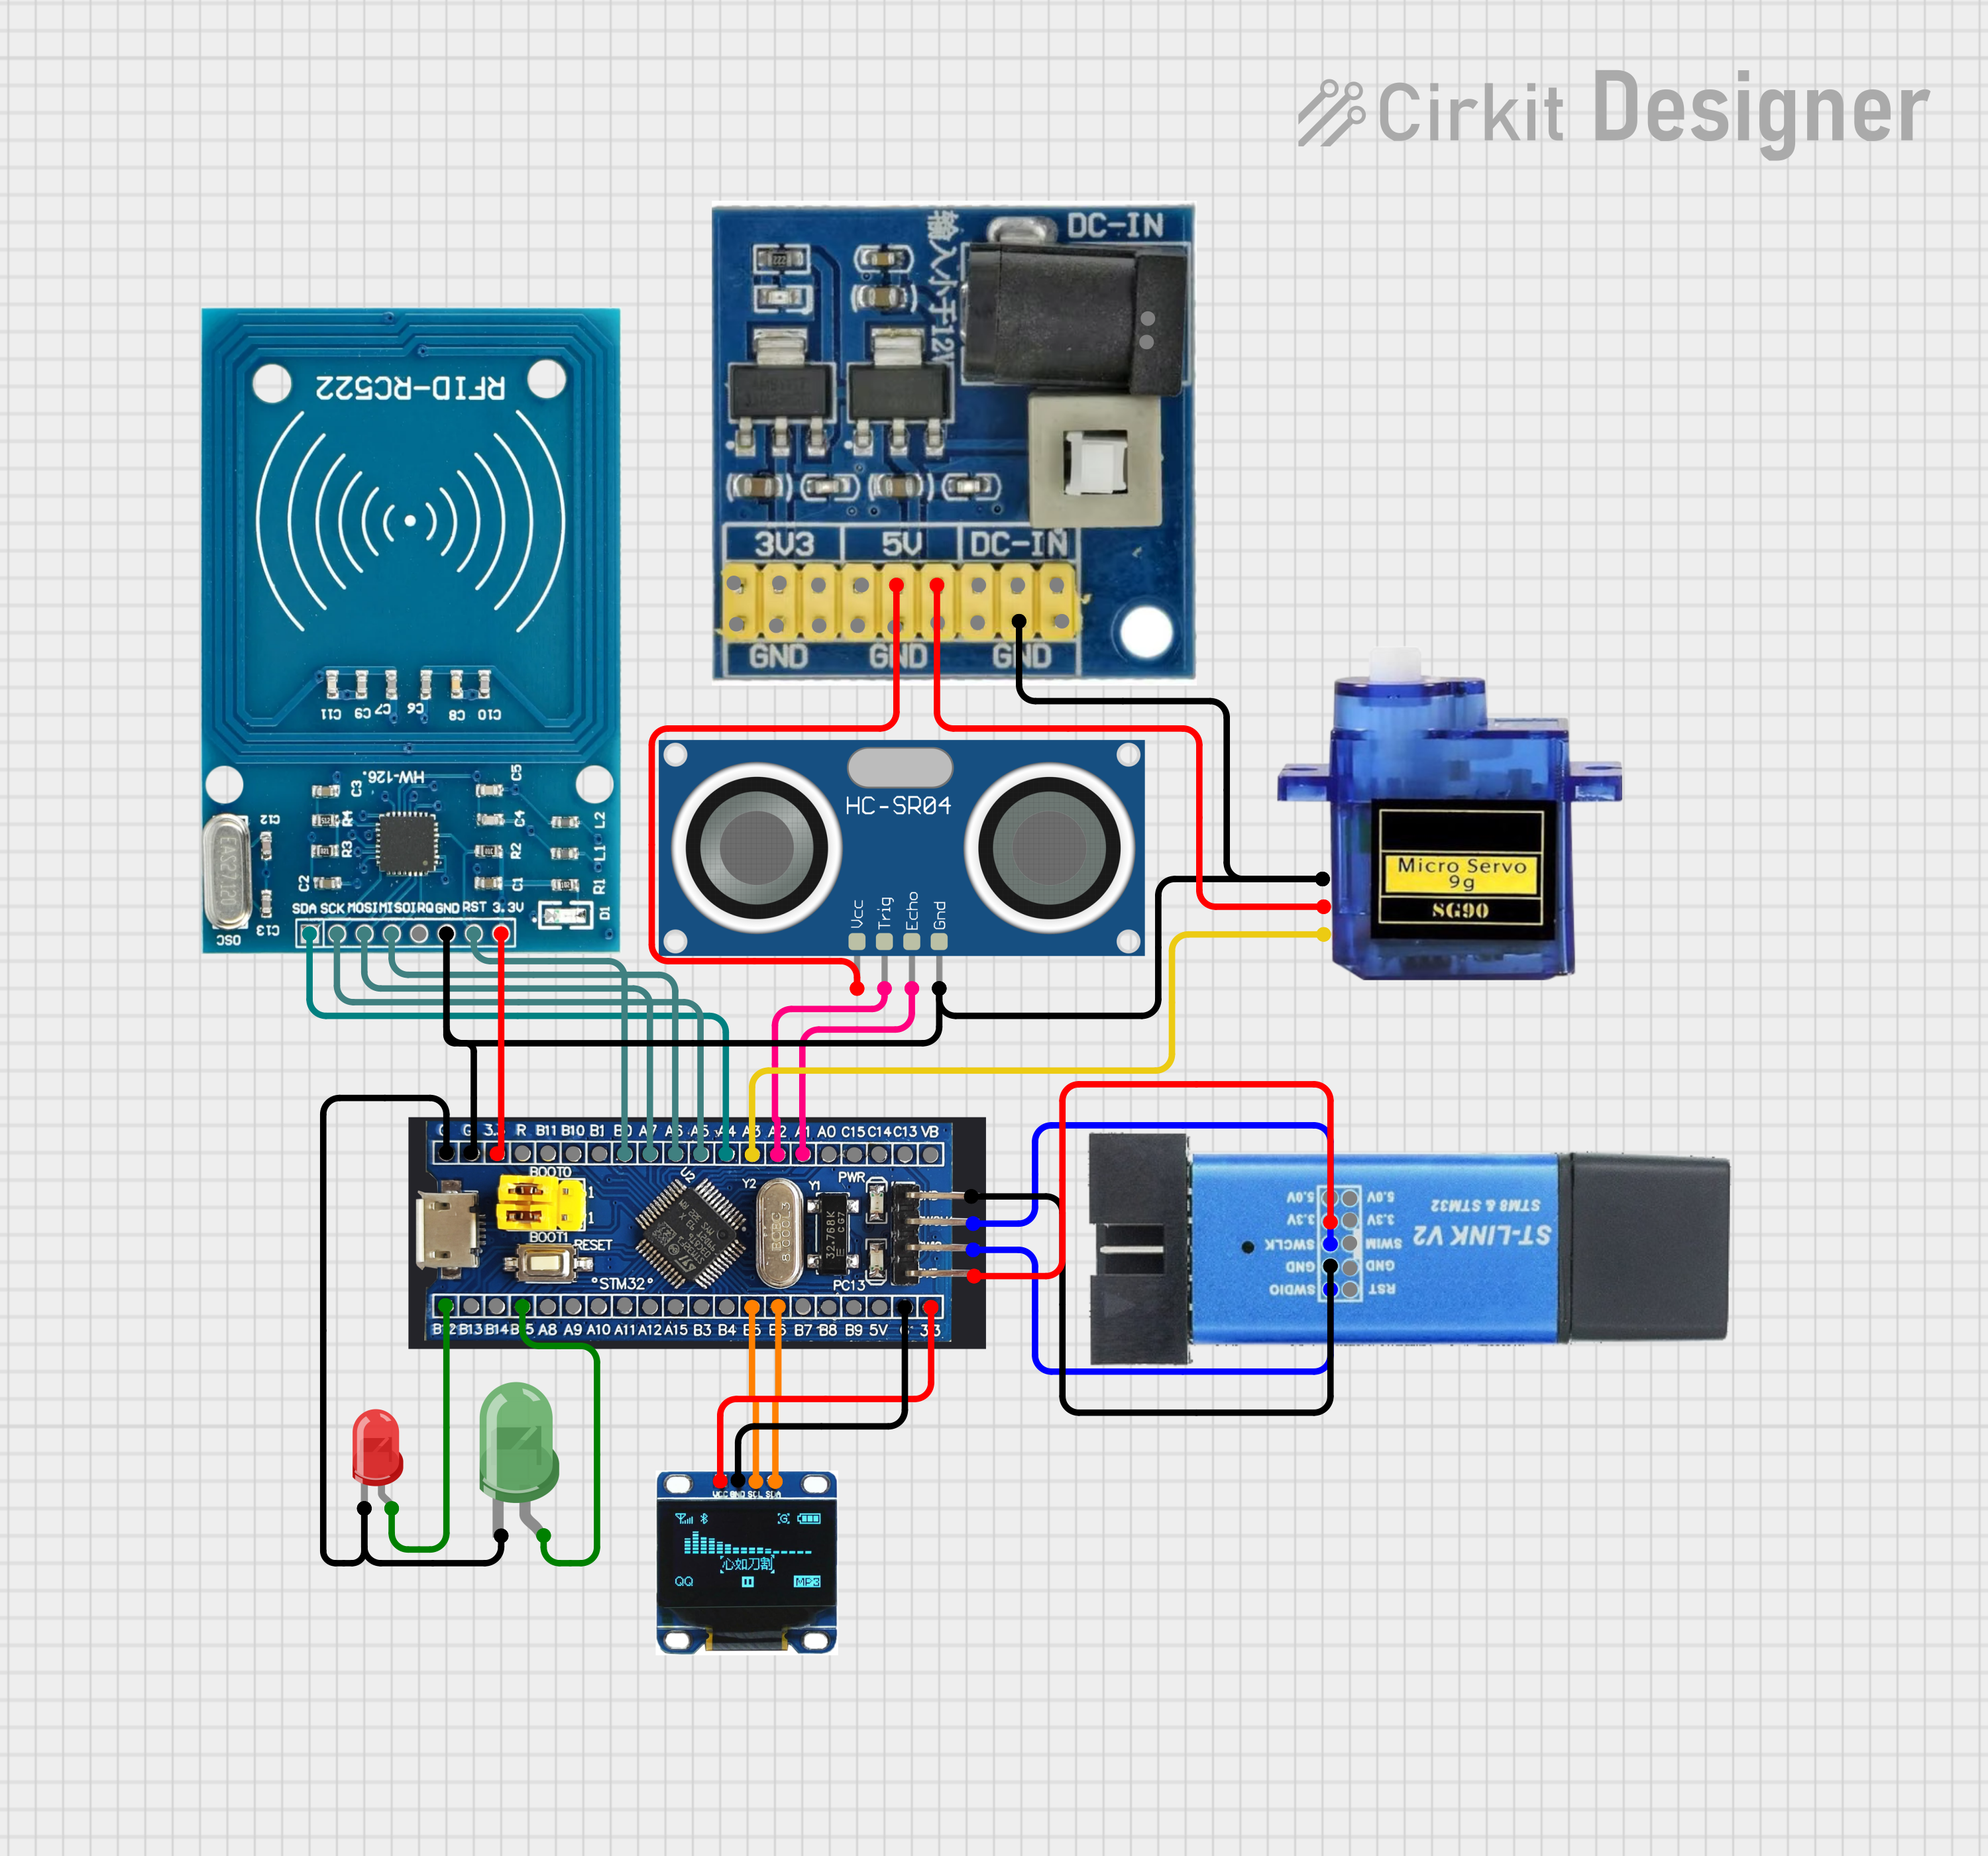**

**Results:**

Test Case: Authorised User

Test Case: Unauthorised User

**Conclusion:**

In conclusion, this project successfully demonstrates a working security door system that uses RFID technology and a servo motor to control access. It meets the main goal of allowing entry only to authorized users, making the system secure and reliable. The design is straightforward and user-friendly, ensuring that it can be easily operated without technical knowledge. Its simple setup makes it cost-effective, while still providing dependable performance. This project can be applied in homes, offices, and other restricted areas, offering an affordable and practical solution for improving security.